**NAME**

**COLLEGE NUMBER**

**Abstract**

The internet is one rich way to find and source information in real time. Whether one intends to gather information about the different stores, shops and shows to attend, the best location address can always be the internet. Tourism is go him income generation economic activities around the world. Countries and states earn richly by showcase and shrining what they naturally own and produce. Sandy beaches, waterfalls, wildlife, historical monuments and artificial cities gave been some of the greatest trims attraction activities of all time.

The hostel industry in most of ether counters have identified these outstanding astound the world and are utilising them to the best of their knowledge and advantage. In Egypt, the pyramids of Giza attract thousands of trousers around the world daily, people would like to see and understand the history of Egypt and all that they have read and armed overtime about Egypt and its cultural practices. In France, tourist like to throng this state for its know magnificence in culture and the cultural industry, the food, the language and the Eiffel tower which have been known as the national iconic attraction site among travellers to the French country. Most countries in Africa like Kenya and South Africa are known to be holders and pride themselves as hosts in a variety of wildlife such as the lions, elephants, gazelles and cheetahs just but to name a few.

Across the West coast of most countries like Bahamas, Havana, Haiti and even costa Rica, have very warm coastal lines where tourist also throng to annually to go and experience tropical warm suchness and sandy beaches away from the cold winters of their respective countries. Asian countries have also been known to host and hold a rich culture of medicine and traditional practices. For instance, tourist around the world throng to Japan, Asia and Korea just to understand and learn from their cultures, their food medicine and cultural are most preferred around the globe by various persons.

Tourism has continued to open a variety of opportunities to persons and individuals in different parts of these states, giving them job opportunities and opening new international business relations to these states. During this study, the researcher went out to develop a common application that would seek to harness the fullness of the wealth and opportunities generated by these countries and the foreseeable future opportunities that such applications are capable of especially in as much as information technology is concerned.

**Introduction**

The United Arab Emirates prides itself as a country that has built itself out of ‘nothing”. From a country of dry lands, sand and heat to an international recognizable, business, hospitality and tourist attraction hub. The UAE has overtime been able to economic build and strategize itself before the globe by improving its appearance and infrastructure, these are items that have overtime been able to attract investors and other developers to come and do business in UAE, by making this setae a hub for their products.

For instance, currently handbags and Gucci material clothing sells well in the UAE personal around the world are willing to pay and arm and a dollar just to fly and do their shopping in the UAE. Another factor that is attracting investors and the world to the UAE are the sandy dines and the sandy deserts, Adventurous and thrillers are all excited by the thought of going to ride camels and ride big bikes in the deserts. As a through way passage for most flights to Europe and even the Americas, Dubai prides itself in some of the best hotels and restaurants where tourists can come and dine, eat and have a view of the city as they pass through on their way to other estimations around the globe.

Expos are one way by which countries benefit from and attract investors to come and run their businesses in their countries. During this year’s Expo, the world agenda has been set in Dubai and persons are making their way to Dubai to view and grab a display of the opportunity that are offered by the UAE. We therefore come up with a system that will guide the tourist to the various hotels, restaurants, eateries and tourist destination sites that are availed within the city. By the end of the day, the proposed system shall have prompted the existing business and given opportunists to the tourist attraction central business a partnerships between potential investors and the possible expositors.

The motivation behind this project implementations was the need to capture the various opportunities from the potential would be investors with the aim of:

* Creating long-term relationships between investors and the expositors
* Opening a window of opportunity for UAE business men to show the world their products and activities
* Create financial opportunities for hotels, restaurants and tourist attraction sites to get more customers during the time when attendees will visit the UAE.

The most interesting concept about this application is the ability to allow /enable investors to view and book opportunities even before they physically present themselves in the UAE. One of the challenges that is likely to be faced during this process is the probability that most investors may be in a position to get access to this application and therefore missing an opportunity to invest with the UAE.

**Literature Review**

**According to** Al-Malkawi et al (2012) there is a great correlation between the economic growth of f UAE and its financial its financial development. Research cutting across the year of 1974 to 2008 measured angst empirical studies indicate that as the UAE been infrastructural growing, so has its financial capability and position as well.

In another article done by Al-Shayeb et al (2016) show that during the years, UAE has continuously continues to step up provides that promote international trade and open bordered investments partnerships together with its partners and investors, in turn, the UAE has seen am increasing ratios of GDP and GNI, all these attributed to the national policies and procedures that the state has put at hand to ensure proper development between its partners.

Yet in another study done by AlMazrouei et al (o2016), revealed that adoption of culture in the UAE was a major contributing factor to the success of expatriates in the UAE, for instance, it was established that cultural elements like the Islam religion, mode of dressing and even the Arabic language were a major contributing factor to the success and growth of the skillset within the Arabic business world. The study summarized that it was easier for hired and strained staff who had assimilated not the Arabic culture to outperform beyond their expected goals and targets unlike their counterparts who had not done the same.

The adoption of retyping in the process of software development is key in understanding the key performances of any application before actual development, as illustrated by Tupia-Astoray et al (2020), prototyping gives the developer an idea of what the expected system would look likely simulating the final model and digitally interacting with it. Prototyping also helps to identify bugs or system fault likens before the system is completely built, this will the development team to have in mind the final expected layout and output of the system he has in mind.

These bugs s that have been identified during prototyping g can be overcome by adopting the right software development methodology e.g. Agile, where repetitive steps are executed and occasionally test end before moving to the next stage of development. While designing a system could of keen interest to the developer, keen attention dials o supposed to be placed on the security features that the system has to offer, a good system is supposed to use the latest developments and programming paradigms that are free of abuse and attacks from malicious users Lins (20218).

**System description:**

In order to solve the problems discussed above during this year’s UAE trade expo, the researcher came up with a web based application system to provide solution sot the would be guests and visitors during this summit. The system follows a modern architecture with usability and user experience in mind. Being user centric, the system takes in the flow of all activities registered by user in a manner that is self-guiding self-explanatory to the user.

The user will first click the link and upload load the webpage in a view browser where he can see all details related to the work that he/she is supposed to do, then, the home page shall load the home page consists of four major layouts, the header with menu items, the hero and banner section, body and finally the footer section. Within the menu items page, the user has the option of selecting a hotel to book, an expo stand to visits and then a tourist attraction site gallery where they can see all the possible available destinations to visit. This particular demonstration is illustrated as below.

Select Expo activity

Book hotel

Pick an expo booth

Book a tour

Book room and service type

Select destination and tour type

Select stall/booth of interest

**Screenshot of the website**

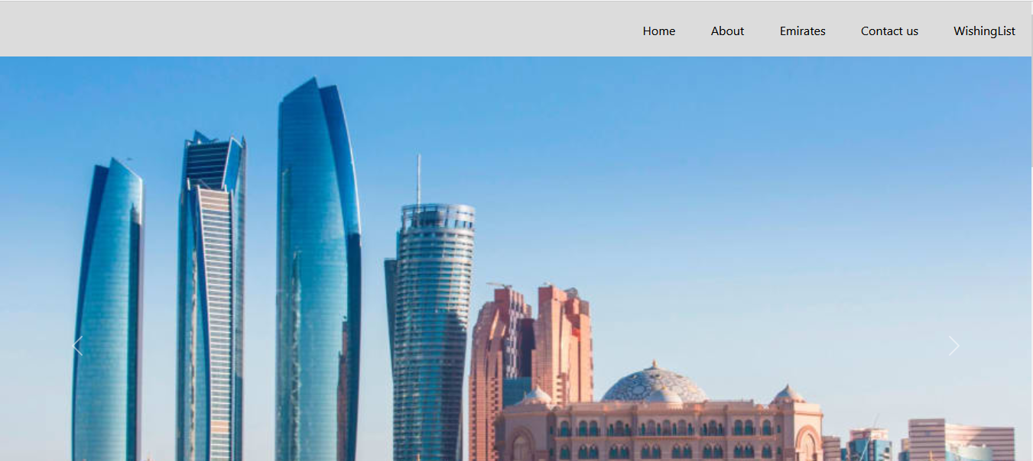

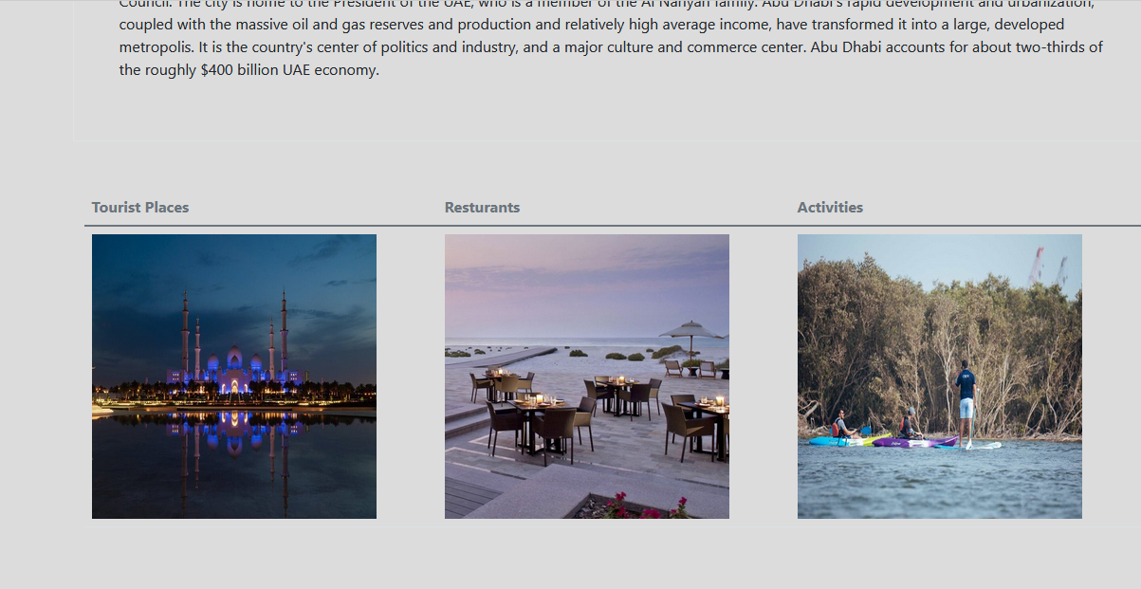

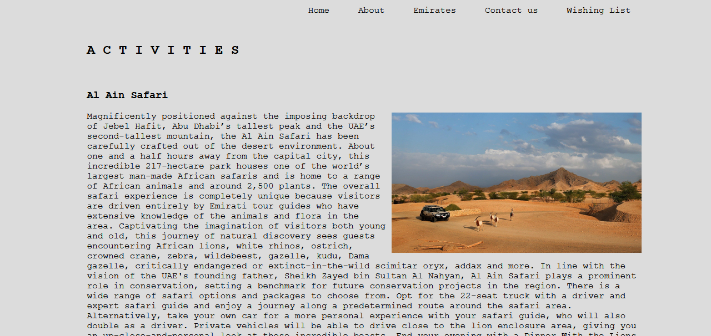

Given the expected outcomes and results from the mock-up UIs, this is a good way to kick off the development process. All the prototypes followed this approach.

**REFERENCES**

Al-Malkawi, H. A. N., Marashdeh, H. A., & Abdullah, N. (2012). Financial development and economic growth in the UAE: Empirical assessment using ARDL approach to co-integration. *International Journal of Economics and Finance*, *4*(5), 105-115.

Al-Shayeb, A., & Hatemi-J, A. (2016). Trade openness and economic development in the UAE: an asymmetric approach. *Journal of Economic Studies*.

AlMazrouei, H., & Pech, R. J. (2015). Working in the UAE: Expatriate management experiences. *Journal of Islamic Accounting and Business Research*.

Tupia-Astoray, A., & Andrade-Arenas, L. Implementation of an e-Commerce System for the Automation and Improvement of Commercial Management at a Business Level.

Lins, F. A., Sousa, E. T., & Rosa, N. S. (2018). A survey on automation of security requirements in service-based business processes. *International Journal of Web Engineering and Technology*, *13*(1), 3-29.